

**ISSS610:**

**Applied Machine Learning**

**Final Report**

Asmit Adgaonkar

Brijesh Gupta

Tan Yan Zhi Clarence

Debasish Behera

Eric Prabowo Cundomanik

Franky Eddy

# ****Abstract****

Big data is one of the most fashionable catch phrases of our time However, unlike many such fads before, there is something valuable at the heart of it. Through our interactions on the internet and web, we are able to gather information on what we all think and do in unprecedented volumes. Despite its high potential, it faces the challenges of making good sense of the data and apply to the real life scenario. This problem is particularly more challenging in unstructured data such as text and words. Therefore, this project aims to experiment and build a series of classifiers such as Logistic Regression, Gaussian Naives Bayes, Random Forest and so on. Based on the results, we will be able to determine what steps are required and which classifiers are most suitable for sentiment analysis and market prediction.

# Introduction

According to the “efficient market hypothesis”, in financial markets profit opportunities are exploited as soon as they arise, hence stock prices follow a random walk and are extremely difficult to predict. However, in the financial market setting the task is rather to generate profitable action signals (buy and sell) than to accurately predict future values of a time series. Technical analysis has always been used to predict future prices based on historical prices, whereas fundamental analysis tends to predict prices based on factors in the real economy (e.g. inflation, trading volume, organizational changes in the company, demand for products or services offered by the company). By incorporating an additional perspective using text analytics and machine learning, an analyst can gain a higher accuracy in predicting future market prices. As textual data (news articles) are getting easily available on the web, a new source of indicators could provide potentially useful information for fundamental analysis. The objective of this project is to analyze and extract such information, and derive numerical indicators from text.

# Problem Definition

Daily news are reported on the web but not much emphasis is placed on analysing these data to generate insights or perspectives in predicting financial market prices. Most of the news reported represent the voice and sentiments of the people. The events reported on the news can have a direct impact on the market but there is a problem of understanding and using such news. Therefore, it is a problem that we would want to analyse and resolve.

# Motivation

The main motivation of this project is to analyse and understand the possible machine learning and text analytics techniques that can be applied to the actual news in order to gain insights of market and text data. Through this project, we would want to understand which techniques provide the best accuracy and score in predicting the stock movements in the near future.

# Data Description

There are three data files in CSV format that is provided from the Kaggle website:

* RedditNews.csv: Historical news headlines from Reddit World News Channel. It has a total of 73,608 count of headlines from the period 06/08/2008 to 01/07/2016. Only top 25 headlines are considered for each date.
* DJIA_tables.csv: Daily rates of Dow Jones Industrial Average (DJIA) from date range 08/08/2008 to 01/07/2016. A total of 7 Columns containing the date, opening stock price, day highest price, day lowest stock price, closing stock price, volume and adjusted close price.
* For the purpose of this project, we will be only using the *Combined_News_DJIA.csv* dataset only as it has already both Reddit News and DJIA table dataset which are necessary for the modelling in later sections. This dataset has a total of 1989 dates, with 25 columns reflecting the ranking of headline in each date(row). Each row has 25 top headlines of each date. Column B, “Label’, reflects the binary classification as below:
  + "1" when DJIA Adjusted Close value rose or stayed as the same
  + "0" when DJIA Adjusted Close value decreased.

# Summary of Approach

In this project, we are applying these methods in order to gain insights on the machine learning techniques that is most accurate in predicting the market prices.

* Data pre-processing: To prepare and train the corpus from the combined news dataset ready for the classification and modelling. The steps will be further elaborated in the later sections.
* Run and experiment the models with different N-Gram and tf-idf features
* Exploratory Analysis is performed to gain perspective visually on the dataset so as to guide the direction of the project
* Based on the exploratory analysis, a variety of classifiers are being applied to the trained dataset
* The classifiers’ results are scored to measure the model with the best accuracy and best recall
* Grid search method is being applied to determine the best parameters for the classifiers for this approach
* Sentiment Analysis Approach is a method applied separately from the rest above to get a better understand of how the negativity and positivity of the news influence the financial markets. This will be further elaborated in later section

# Data pre-processing steps

Below are the steps being applied to Combined_News_DJIA.csv dataset to prepare the corpus for model fitting and analysis. As mentioned earlier in the dataset description, this dataset will be only be used for this project as it has provided the labels. In the pre-processing stage, we will perform Stopwords removal, word stemming and data partition.

## Preparing the corpus:

* StopWords Removal:

A lexicon of “English” stopwords provided by NLTK is being used for identifying and subsequently removing the extremely common words that appear to be of little value. Example of such words are like “the”, “a”, “and” etc

* Word Stemming:

This method is to build a vocabulary of unique words entails identifying the word stems and de-duplicating derived words. The goal is to reduce words in their different form into a common base form to extract useful statistics for the input text.

* Data partition (Train and Test):
  + After applying the steps above, the data is being split such as :
    - Training dataset: News reported before 2014-12-30
    - Testing dataset: News reported after 2014-12-30

## Feature Representation:

The purpose of the feature representation is to transform the processed dataset into a feature set that is usable by the classifiers. We have utilized the following approaches to aid us in constructing the feature sets.

### Bag-of-Words(BOW) & TF-IDF:

A BOW Representation is a method that essentially transforms the list of words into a feature set. It was used on a fixed vocabulary to represent the combined news for each day. Since BOW method with word count gives equal weightage to each word, there could be rare words and phrases that possess higher value information as compared to the common words. As such, we add a simple twist on top of bag-of-words model. Instead of looking at the raw counts of each word in each document, tf-idf looks at the normalized count where each word count is divided by the number of documents this word appears in. The illustration is as below.

* + bow(w, d) = # times word w appears in document d
  + tf-idf (*w*, *d*) = bow(*w*, *d*) * log (*N* / # documents in which word *w* appears)

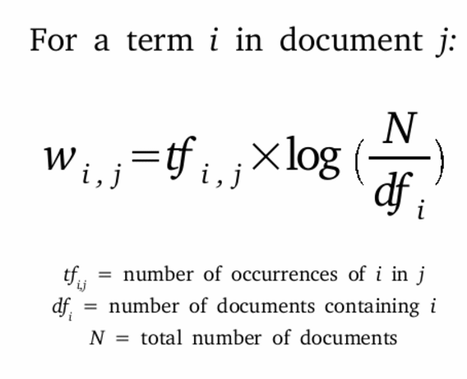

The intuition behind this is to make rare words more prominent and ignore the common words effectively in the Reddit News dataset.

### Part-Of-Speech Tagging(POS)

The semantic and syntax of the sentences can reveal different insights. Therefore, it makes sense to capture and analyse all the POS tag to understand how it fits with the overall prediction and model building. Researchers also found that certain POS Tags such as nouns, carried more weightage in prediction than the others. By choosing the only the nouns, we are effectively selecting the most representative words and thereby curtailing the noise in the sentences. Inline with this reasoning, we further fitted a variety of models only with prominent noun words.

### N-Gram Selection

A N-Gram is contiguous sequence of ‘n’ items from a given sequence of text or speech. We have used a combination of 1-gram & 2-gram for BOW and TF-IDF model.

# Exploratory Analysis

In this section, we would explore the attributes of the dataset to gain a better understanding of what the corpus contains. The purpose of the various analyses as below allow us to understand the dataset better.

## Word Count Analysis

Based on the histogram (Fig 1) below, the average word count is centered around 300 words. Label “0” seems to be slightly skewed to the right and the distribution of the word count is close to a normal distribution. In Fig 2, it represents the distribution of shared words with both labels also being close to normal distribution. The average word count is around 30-40 words. This shows that for label ‘1’ and label ‘0’, the distribution are pretty similar.

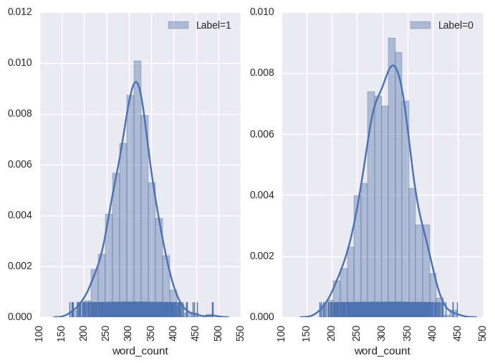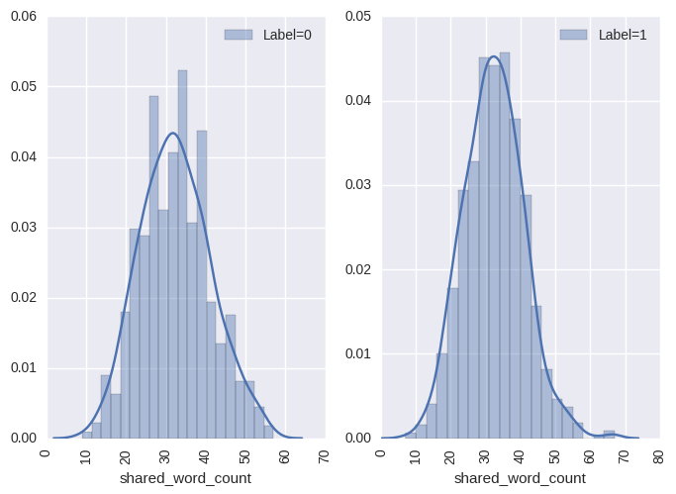

Fig 1 Fig 2

## Box Plot Analysis

Based on the boxplot (Fig 3) below, there is more variation of the word counts for Label “1”. In the shared words box plot(Fig 4), there is not much difference between the classes.

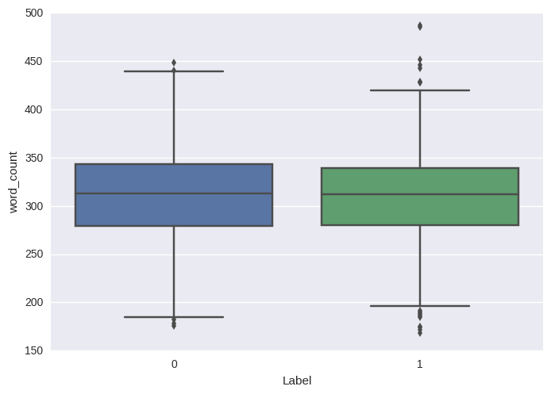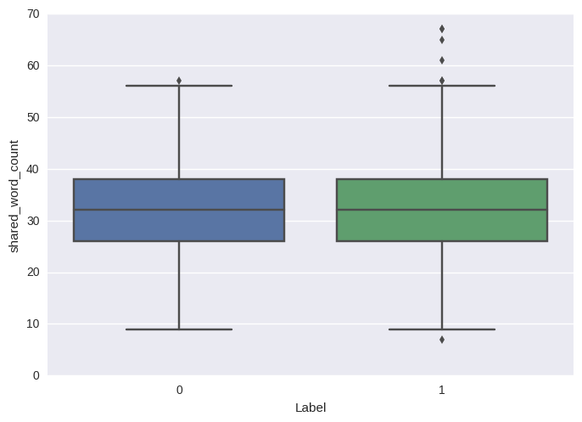

Fig 3:Word Count Fig 4: Shared Word

## Distribution of POS Tags

In both Fig 5 and 6, the distribution of POS Tags for both labels are very similar. The most dominant POS tags are the nouns and adjectives. The NN in the figures represent nouns and it can be seen in both distributions as the tallest bar. This can be noted that there are more information that can be gathered looking at the nouns in this dataset.

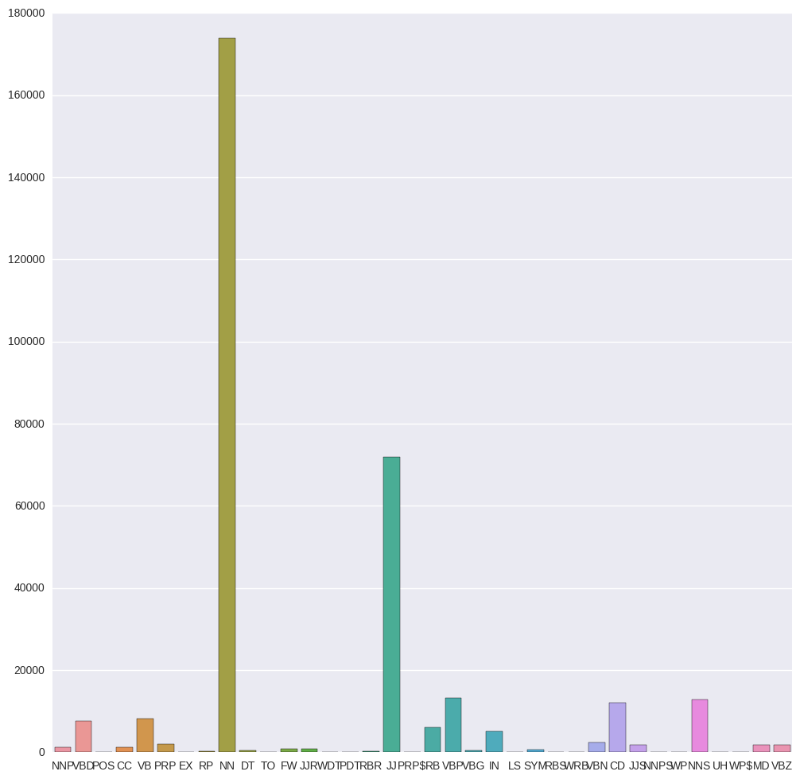

Fig 5: Label “1” Distribution Fig 6: Label “2” Distribution

## Word Cloud Visualization

Based on the word cloud visualization, we are able to see which words are more prominent based on the different n-gram and tf-idf features. There were words that took us by surprise such as the vulgar words presented in the wordcloud. This tells us that the Reddit News did not only contain formal headlines but informal and expressive ones as well. As such, we believe that such expressions would undermine the quality of the dataset as it is not being consistent. Nonetheless, we would still attempt to analyse which classifiers work best for this dataset.



Fig 7: Word Cloud

# Models applied

Below are the models with the parameters that we derived iteratively by performing multiple runs on the models using grid search and choosing the one with best results. Through multiple iterations, we selected the parameters that yields the best results thus far.

1. Logistic Regression with parameters: C=0.000001, solver=’liblinear, max_iter:200
2. K-Neighbours Classifier (3)
3. Multinomial Naives Bayes
4. Decision Tree Classifier
5. Random Forest Classifier with parameters: n_estimators=250. oob_score=True
6. AdaBoost Classifier with parameters: DecisionTreeClassifier(max_depth = 2), n_estimators =10, algorithm:‘SAMME.R’, random_state : 2017)
7. Bagging Classifier
8. Gaussian Navies Bayes

# Results

## Model Accuracy

### Classifiers performance with tfidf weighted BOW representation for ngram = 1 and 2

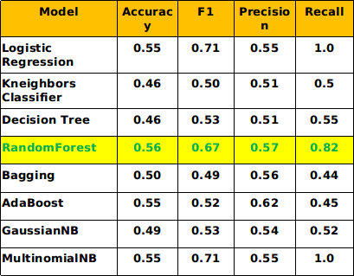 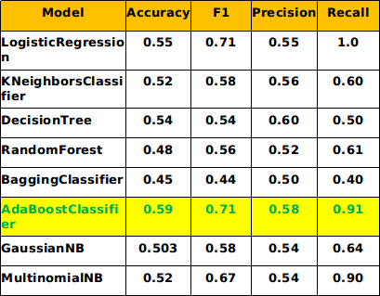

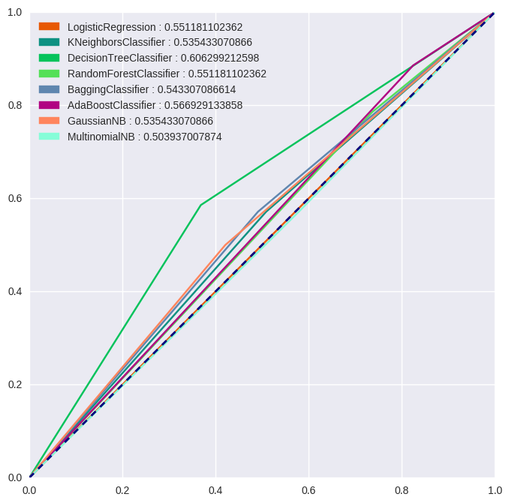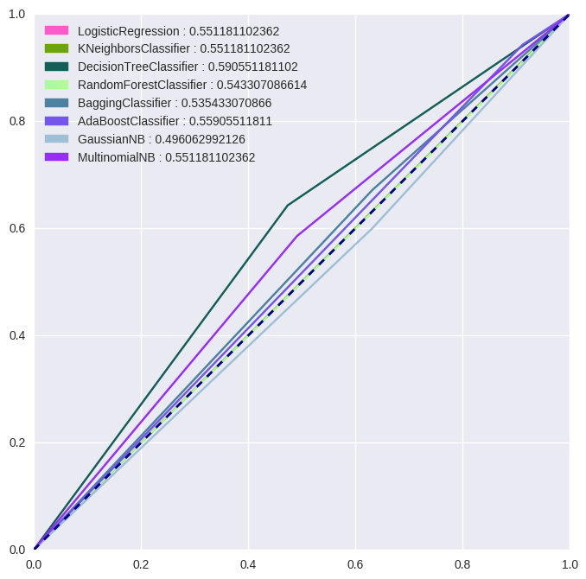

Fig 8: N-gram = 1 Fig 9: N-gram =2

Based on the ROC curve and accuracy table above, the Random Forest Classifier yields the best accuracy score of 0.56 when N-Gram is equal to 1 and a score of 0.5905 when N-Gram is equal to 2. A noticeable improvement can be seen in the accuracy and ROC curve with N-gram = 2 representations implying phrases rather than words have more influence in predicting the market. However, we do note that the recall value for random forest when n-gram is 1 and AdaBoost Classifer for n-gram is significantly high at 0.82 and 0.91 respectively. In this aspect, we can assume that dataset is most sensitive to these two classifiers

## Semantic Analysis

Some of the research [4] shows certain named entities like Noun phrases and words seem to have more predictive power than other POS. One reason for this being Nouns are the most representative part of speech in most of the text and can therefore succinctly summarize the entire text; thereby reducing the dimension and eliminating noise. Therefore, we extracted all the noun phrases using NLTK’s POS taggers and built a reduced corpus of only noun phrases.

Building on only these noun words, we see some improvement in the accuracy and ROC curve as below.

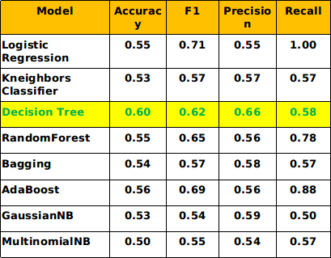 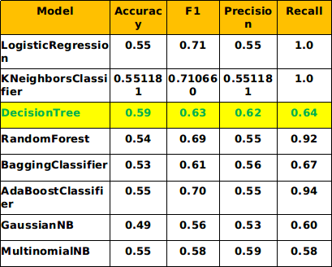

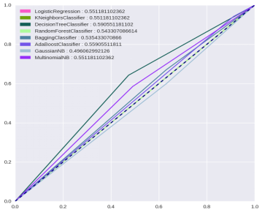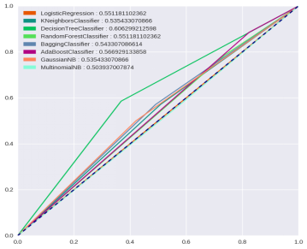

Fig 10: N-gram = 1 Fig 11: N-gram =2

We do see significant improvement in the accuracy for ngram = 1 representation with best accuracy increased from 56% to 60% but no distinct improvement for ngram = 2 representation. One reason for this could be because, as can be seen from the POS distribution in Exploratory analysis section, nouns form the most dominant POS tags and therefore even after extracting the nouns not much reduction in the dimension was observed.

In order to obtain better computational efficiency and attempt to improve the classification results, two methods of dimension reduction processes, PCA and Truncated SVD, were being applied to the semantic analysis. However, classification results from both PCA and Truncated SVD reveal a lower accuracy than previous classification results, thus it is a direction that we decided not to further explore as it will not improve our findings.

## Sentiment Analysis

In this section, we will explore the use of sentiment analysis to understand how the sentiment weight affects the classifiers. Based on the histogram below, there is a similar distribution of sentiment score for both labels of the “up” and “down” market. In the factor plot, there is an interaction between the positive and negative labels.

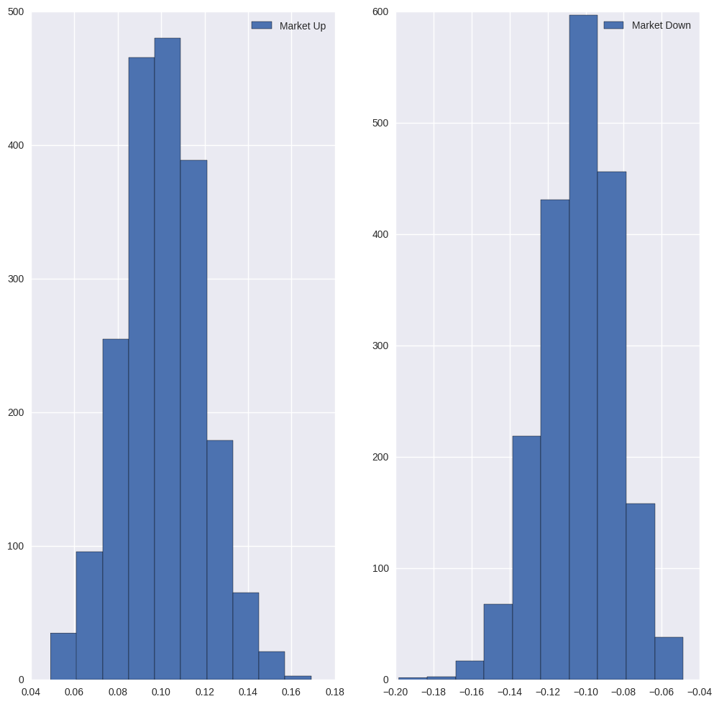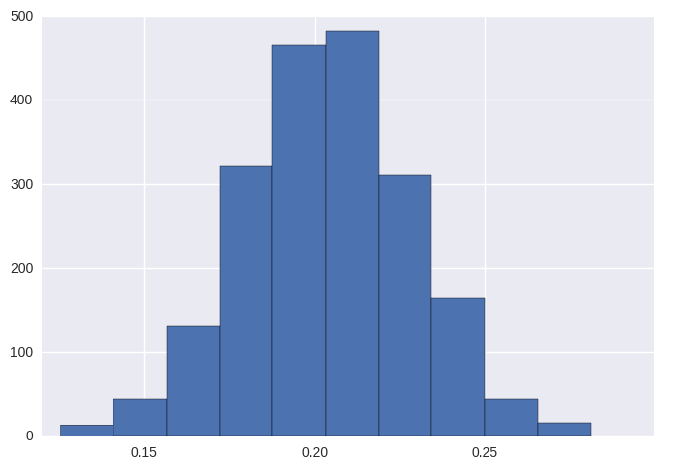

Both the positive and negative sentiments in the corpus shows a strikingly similar distribution. However, the distribution for net positive sentiment is slightly skewed to the right.

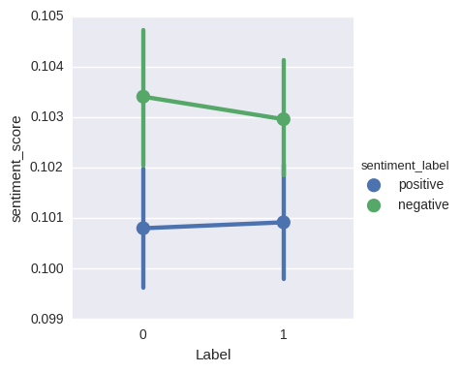

From the above factor plot diagram, it appears that there is a reduction in negative sentiment when the market is up vis-à-vis when the market is down.

**Building model with only net sentiment**

From above its pretty clear that sentiment score can be a good feature in predicting the market movement. We therefore built the models using only this net sentiment score.

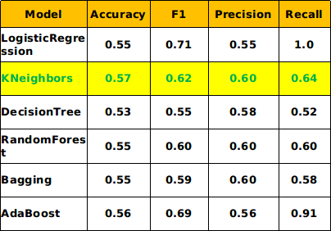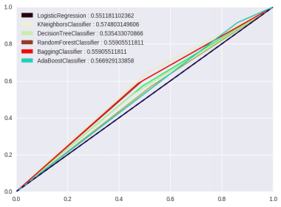

*Model Performance and Accuracy with only net sentiment score*

The model shown above is only using the sentiment score; the accuracy is not as good as the n-gram = 2 with tf-idf but it still performs a good enough classification with an accuracy score of 56.6%. It would be worthwhile to apply sentiment analysis along with tf-idf representation. However, it will be necessary to force the classifiers to use the sentiment score features when using alongside the massive vocabulary. To enforce the sentiment score on the model, we have weighted the sentiment by multiplying with a large number and then using it alongside with BOW method as an additional feature.

Below is the plot of the accuracy and F1 score for different weights applied to sentiment. A large variation can be seen in the accuracy and F1 score for most of the classifiers while some appears to be unaffected (for eg, Logistic and AdaBoost).

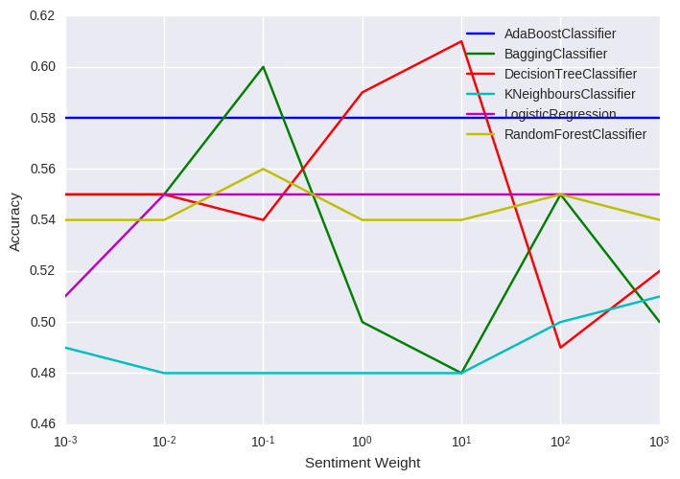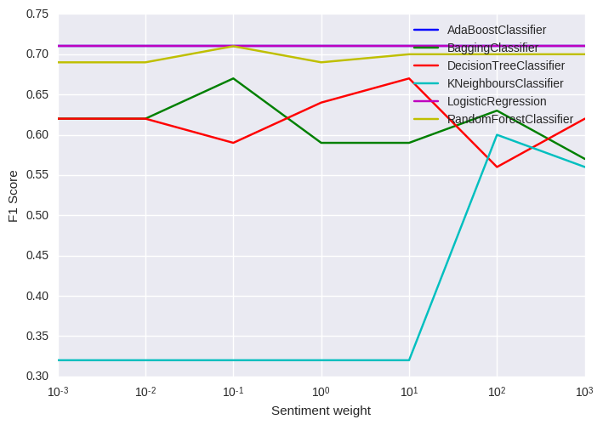

In the graphs below, we see a slight increase in the accuracy and F1 score for AdaBoost by including the sentiment score. This indicates that sentiment score have a slight influence on the accuracy scores.

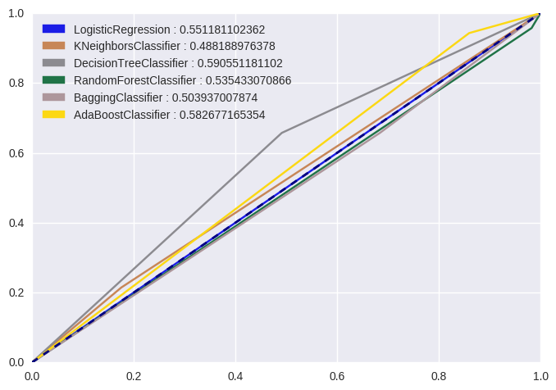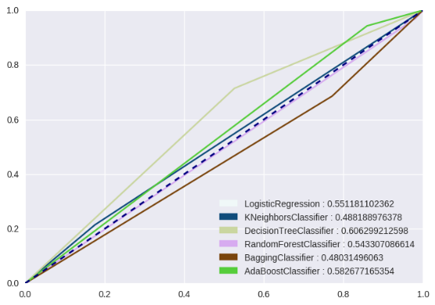

In the below, the ROC curve represents the models of different values of the sentiment weights. Out of all the models, AdaBoost classifier seems to have the best performance of classifying the labels but was insensitive to the applied weights.

# Challenges

1. The news data failed to provide timestamp for the given days, and hence was difficult to relate whether the news was during the market hours or post market hours.
2. Topic modelling failed to provide any prominent topics for the entire corpus(8years) however we were still able to reduce corpus dimension by applying and extracting only specific POS tags.
3. Because of limited lexicon, it was difficult to accurately perform Semantic and Sentiment analysis.
4. Source of news are combination of informal and formal news which poses some difficulty in our analysis.
5. Another challenge we identified is the inherent randomness in the results at every run. Many of the models were probabilistic and each run shows a different random results, thus making it difficult to present a consistent and coherent picture. To circumvent this issue, we averaged the results over few iterations. The summary of results presented in the last section are the average reults in each case.

# Conclusion and Future Work

In this project, we ran through multiple iterations and explored many areas to improve the accuracy score of the predictions. It is indeed difficult due to the limitations of the dataset we have chosen for this project despite deploying a variety of methods to improve the results. Nonetheless, it is still a good finding and helps to formulate directions for other similar projects in the future. Below is the summary of our results:

* Using Noun phrases BOW tfidf representation shows improvement over all words BOW tfidf representation at accuracy of 60% with DecisionTree classifier.
* In most of the representations ngram = 2 shows superior performance over ngram = 1 implying phrases rather than words have more predictive power.
* Including sentiment score to the BOW shows distinct improvement in the accuracy and overall predictive power of the model.
* Amongst all the models, AdaBoost and Decision Tree Classifers show the best overall score amongst all representations.
* Based on the current results, we are certain that there is a lot of potential in utilizing machine learning techniques and text analytics to provide us insights in helping us to predict market prices. The world of unstructured data has a huge potential in affecting stock prices as news tends to have an effect on the behaviour of the market. Future work can be done in terms of collection of data so that it can increase the accuracy of the classifiers as the current dataset simply takes the daily top 25 headlines which are not so helpful in gaining insights to predict stock movements.

# References

1. <https://www.researchgate.net/publication/228892903_Using_news_articles_to_predict_stock_price_movements>
2. <http://www.pnas.org/content/111/32/11600.full.pdf>
3. <https://www.kaggle.com/aaron7sun/stocknews>
4. <http://citeseerx.ist.psu.edu/viewdoc/download;jsessionid=A3F6F19EFCF2A97A064C1796AFAFD092?doi=10.1.1.333.3366&rep=rep1&type=pdf>